Danny Tan

AI Fall 2018

HW # 7

Problem 1:

P(M=1) = (2+3+12+8) /100 = 0.25

P(M=2) = (8+4+1+6+6)/100 = 0.25

P(M=3) = (4+2+3+6+25+10)/100 = 0.5

P(M=1) \* P(A=1| M =1) \* P(D=2 | M=1) \* P(C=F | M =1) \* P(R=1| M=1)

0.25 \* 0.02 / 0.25 \* 0.22/0.25 \* 0.02/0.25 \* 0.15/0.25 = 0.0008448

P(M=2) \* P(A=1| M =2) \* P(D=2 | M=2) \* P(C=F | M =2) \* P(R=1| M=2)

0.25 \* 0.12/0.25 \* 0.24/0.25 \* 0.12/0.25 \* 0.15/0.25 = 0.0331776

P(M=3) \* P(A=1| M =3) \* P(D=2 | M=3) \* P(C=F | M =3) \* P(R=1| M=3)

0.5 \* 0.06/0.5 \* 0.47/0.5 \* 0.12/0.5\* 0.17/0.5 = 0.00460224

Naïve Bayes would classify this instance as M =2 since that gives the maximal probability.

Problem 2:

2a)

1-nearest neighbors will classify Point A as red

1-nearest neighbors will classify Point B as red

1-nearest neighbors will classify Point C as blue

1-nearest neighbors will classify Point D as red

3-nearest neighbors will classify Point A as red

3-nearest neighbors will classify Point B as blue

3-nearest neighbors will classify Point C as red

3-nearest neighbors will classify Point D as blue

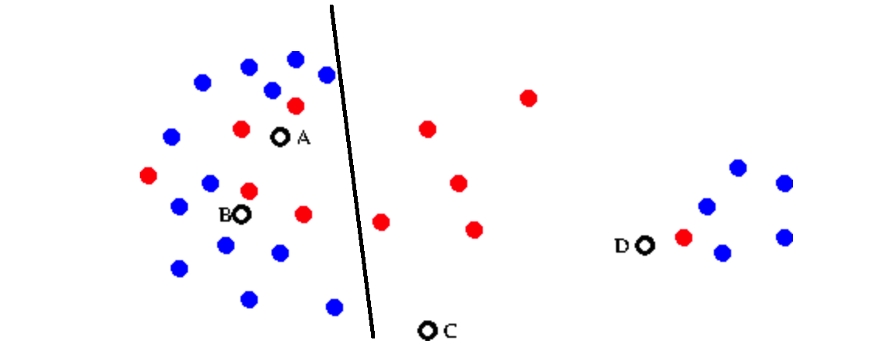

29 total points

5 misclassify red dots and 5 misclassify blue dots

Accuracy is 65.5%

It will classify A and B as blue

It will classify C and D as red